KJSCE/IT/SYBTech/SEM IV/AD/2020-21


Experiment No.2

Title: Execution of In-memory database queries

Page No:

KJSCE/IT/SYBTech/SEM IV/AD/2020-21

Batch: B2 Roll No.:1914078 Experiment No.:2

Aim: To execute In-memory database queries ___________________________________________________________________________

Resources needed: MySQL
___________________________________________________________________________

Theory

In-Memory database is a database that uses a system's main memory for data storage rather than the disk-based storage typically utilized by traditional databases. In-memory databases, or IMDBs, are frequently employed in high-volume environments where response time is critical, as access times and database requests are typically considerably faster when system memory is used as opposed to hard disk storage.

The traditional databases and in-memory databases can be used together and referred as hybrid databases, which support both in-memory and disk-based storage in order to maximize performance as well as reliability of the system. All most all RDBMS systems available in market supports In-Memory databases.


MySQL In-Memory database:

In MySQL DB, the MEMORY storage engine creates special-purpose tables with contents that are stored in memory. Because the data is vulnerable to crashes, hardware issues, or power outages, use of these tables are limited to temporary work areas or read-only caches for data pulled from other tables.

A typical use case for the MEMORY engine involves these characteristics:

- Operations involving transient, non-critical data such as session management or caching. When the MySQL server halts or restarts, the data in MEMORY tables is lost.

- In-memory storage for fast access and low latency. Data volume can fit entirely in memory without causing the operating system to swap out virtual memory pages.

- A read-only or read-mostly data access pattern (limited updates).

- MEMORY tables cannot contain BLOB or TEXT columns.

To create a MEMORY table, specify the clause ENGINE=MEMORY on the CREATE TABLE statement.

CREATE TABLE EMP (emp_Id INT, name CHAR (30)) ENGINE = MEMORY;

As indicated by the engine name, MEMORY tables are stored in memory. They use hash indexes by default, which makes them very fast for single-value lookups, and very useful for creating temporary tables. However, when the server shuts down, all rows stored in MEMORY tables are lost. The tables themselves continue to exist because their definitions are stored in .frm files on disk, but they are empty when the server restarts.

Page No:

KJSCE/IT/SYBTech/SEM IV/AD/2020-21

To load the data in memory from other existing table use,

CREATE TABLE EMP (emp_Id INT, name CHAR (30))) ENGINE=MEMORY as SELECT * FROM EMP;

To move the data from In-Memory table to hard drive (using any text file) use the following syntax,

SELECT * INTO OUTFILE ''emp_data.txt' FROM EMP;

To populate a MEMORY table when the MySQL server starts, use the INFILE option. For example,

LOAD DATA INFILE 'emp_data.txt' INTO TABLE EMP;

Where, emp_data.txt is a data file.

_______________________________________________________________________

Procedure:
Perform following tasks:

- Create In-memory table using Engine as Memory.
- Insert values in that table.
- Attempt to retrieve values from the table after restarting the database server.
- Load the data into table using file load.

________________________________________________________________________

Results: (Program printout with output)

CREATE TABLE EMP (emp_Id INT, name CHAR (30)) ENGINE = MEMORY;

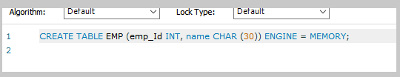

INSERT INTO EMP VALUES (1, "Rohan");
INSERT INTO EMP VALUES (2,"Sammy");

SELECT * INTO OUTFILE 'emp_data.txt' FROM EMP;

Data is stored in emp_data.txt which is stored in “C:/Program Data/MySQL/MySQL Server 8.0/Data/{database_name}”
For me database_name was “test1”

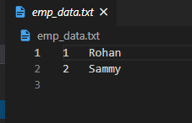

SELECT * FROM EMP;

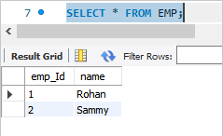

Restarted MySQL server using Services
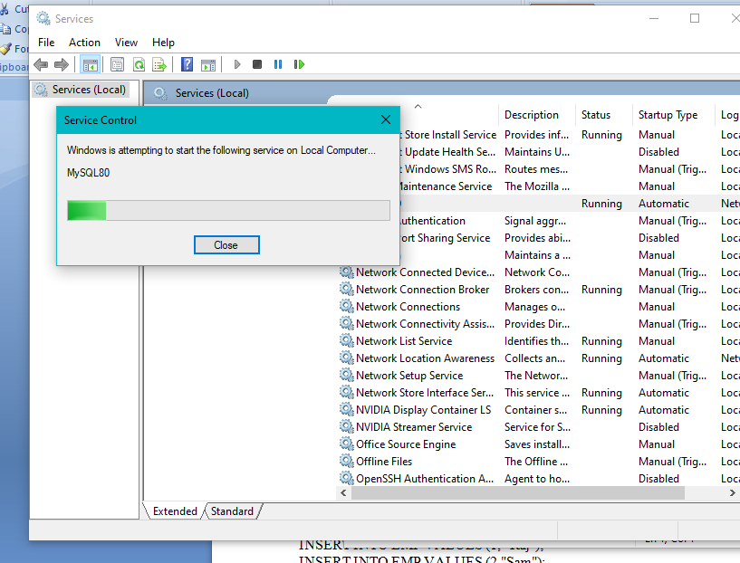

SELECT * FROM EMP;
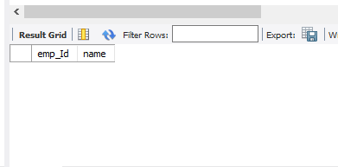

As expected, the table does not contain any of the data previously stored in it.

LOAD DATA INFILE 'emp_data.txt' INTO TABLE EMP;
SELECT * FROM EMP;
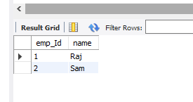
MySQL successfully extracted the data from the “emp_data.txt” and load the table “EMP” with data

___________________________________________________________________________

Questions:

1. What is the difference between traditional and In-memory databases?
In-Memory Databases | Traditional databases
All data stored in main memory, no need to perform disk I/O to query or update data. | All data stored on disk, disk I/O needed to move data into main memory when needed.
Data is persistent or volatile depending on the in-memory database product. | Data is always persisted to disk.
Optimized for specialized workloads; i.e. communications industry-specific HLR/HSS workloads. | Support very broad set of workloads, i.e. OLTP, data warehousing, mixed workloads, etc.
Specialized data structures and index structures assume data is always in main memory. | Traditional data structures like B-Trees designed to store tables and indices efficiently on disk.
Database size limited by the amount of main memory. | Virtually unlimited database size.

_______________________________________________________________________

Outcomes:
Design advanced database systems using Parallel, Distributed and In-memory
Databases and its implementation

Conclusion: We learned about In-memory databases and related queries and executed it on a MySQL database.

Grade: AA / AB / BB / BC / CC / CD /DD

Signature of faculty in-charge with date
___________________________________________________________________________
References:

- https://dev.mysql.com/doc/refman/5.5/en/memory-storage-engine.html
- http://opensourceforu.efytimes.com/2012/01/importance-of-in-memory-databases/
- http://pages.cs.wisc.edu/~jhuang/qual/main-memory-db-overview.pdf
- http://docs.memsql.com

Page No:
Error Code: 1046. No database selected Select the default DB to be used by double-clicking its name in the SCHEMAS list in the sidebar.
Error Code: 1290. The MySQL server is running with the --secure-file-priv option so it cannot execute this statement

